1.#include <stdio.h>

void print_binary(int number) {

if (number == 0) {

printf("0");

return;

}

int mask = 1 << 30;

int started = 0;

while (mask > 0) {

if (number & mask) {

printf("1");

started = 1;

} else if (started) {

printf("0");

}

}

}

int main() {

int input_number;

printf("Enter a number: ");

scanf("%d", &input_number);

printf("Binary representation: ");

print_binary(input_number);

return 0;

}

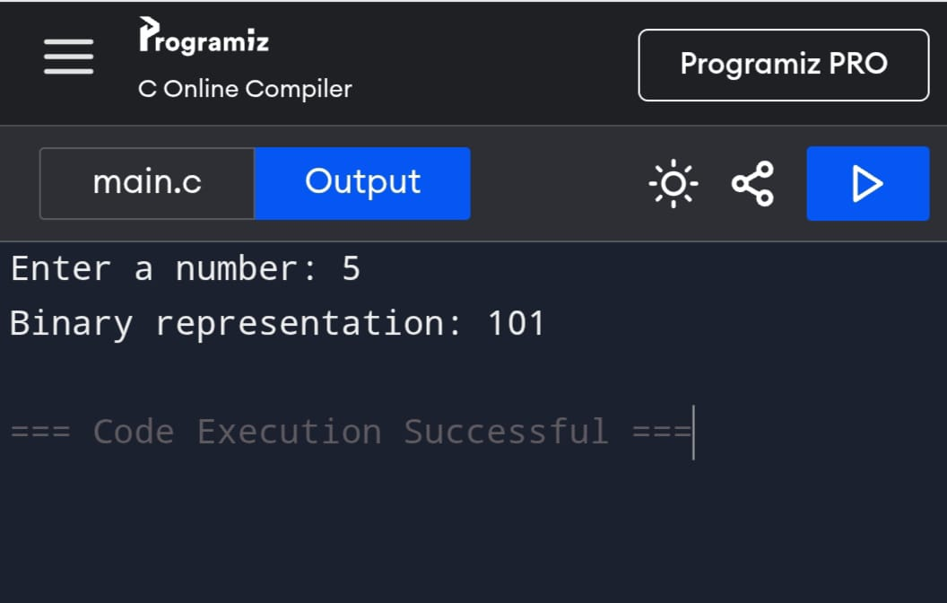

2.#include <stdio.h>

#include <ctype.h>

void count_vowels_and_consonants(char *str, int *vowel_count, int *consonant_count) {

*vowel_count = 0;

*consonant_count = 0;

while (*str != '\0') {

char ch = tolower(*str);

if (ch >= 'a' && ch <= 'z') {

if (ch == 'a' || ch == 'e' || ch == 'i' || ch == 'o' || ch == 'u') {

(*vowel_count)++;

} else {

(*consonant_count)++;

}

}

str++;

}

}

int main() {

char str[100];

int vowels = 0, consonants = 0;

printf("Enter a string: ");

fgets(str, sizeof(str), stdin);

count_vowels_and_consonants(str, &vowels, &consonants);

printf("Number of vowels: %d\n", vowels);

printf("Number of consonants: %d\n", consonants)

return 0;

}

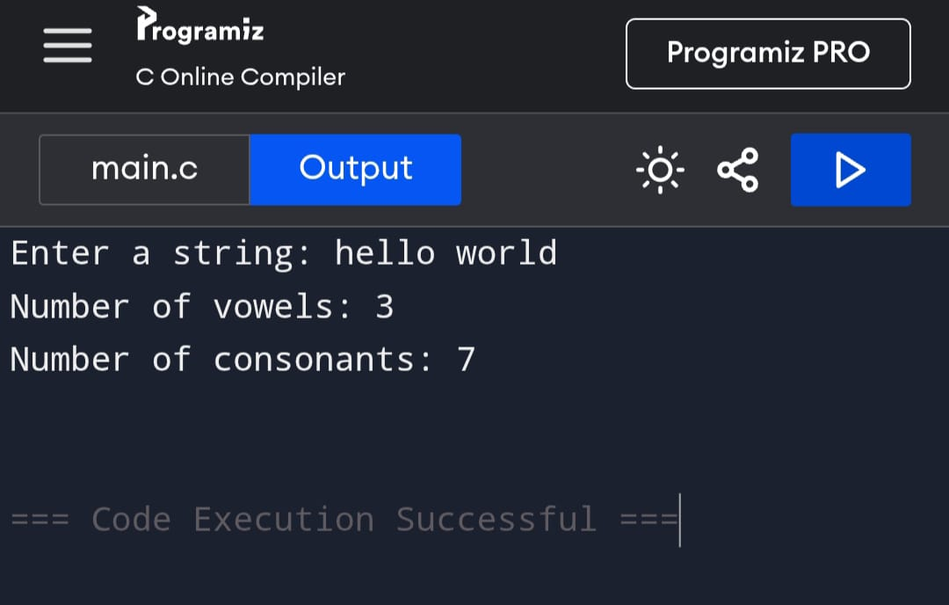

3.#include <stdio.h>

void addition();

void subtraction();

void multiplication();

void division();

int main() {

int choice;

do {

printf("\nMenu:\n");

printf("1. Addition\n");

printf("2. Subtraction\n");

printf("3. Multiplication\n");

printf("4. Division\n");

printf("5. Exit\n");

printf("Enter your choice: ");

scanf("%d", &choice);

switch (choice) {

case 1:

addition();

break;

case 2:

subtraction();

break;

case 3:

multiplication();

break;

case 4:

division();

break;

case 5:

printf("Exiting the program. Goodbye!\n");

break;

default:

printf("Invalid choice. Please try again.\n");

}

} while (choice != 5);

return 0;

}

void addition() {

double num1, num2;

printf("Enter two numbers: ");

scanf("%lf %lf", &num1, &num2);

printf("Result: %.2lf\n", num1 + num2);

}

void subtraction() {

double num1, num2;

printf("Enter two numbers: ");

scanf("%lf %lf", &num1, &num2);

printf("Result: %.2lf\n", num1 - num2);

}

void multiplication() {

double num1, num2;

printf("Enter two numbers: ");

scanf("%lf %lf", &num1, &num2);

printf("Result: %.2lf\n", num1 * num2);

}

void division() {

double num1, num2;

printf("Enter two numbers: ");

scanf("%lf %lf", &num1, &num2);

if (num2 != 0) {

printf("Result: %.2lf\n", num1 / num2);

} else {

printf("Error: Division by zero is not allowed.\n");

}

}

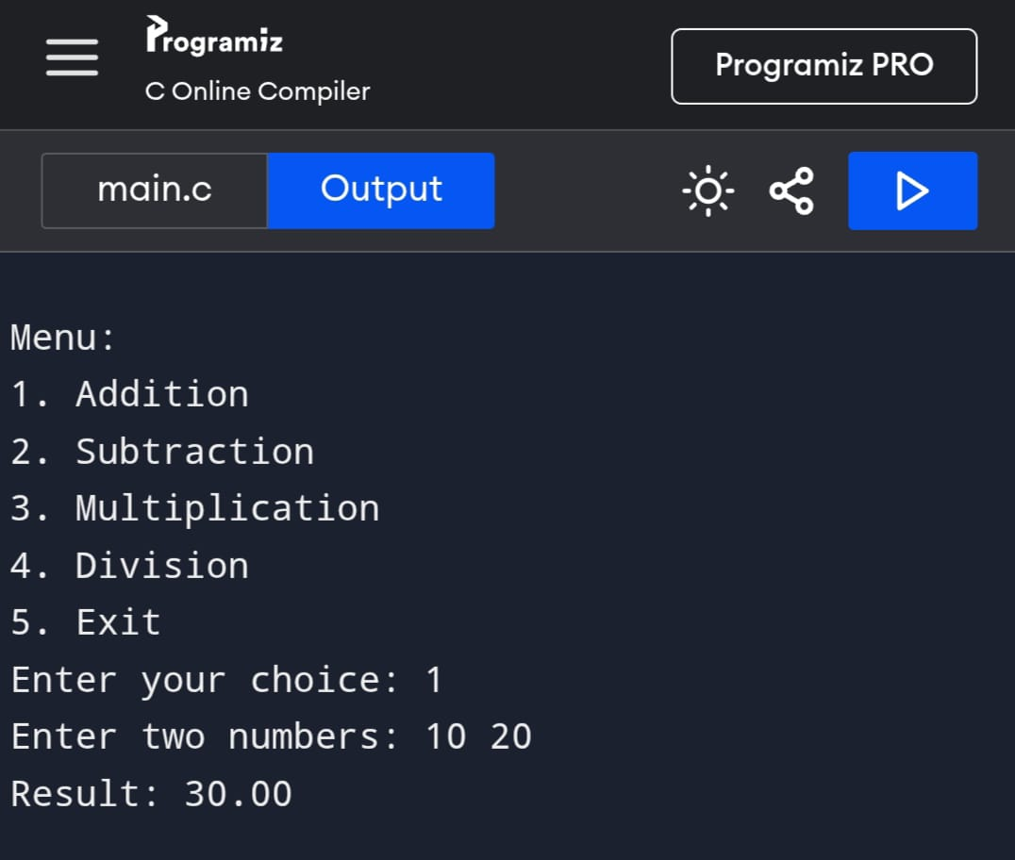

4.#include <stdio.h>

void print_diamond(int n) {

for (int i = 1; i <= n; i++) {

for (int j = i; j < n; j++) {

printf(" ");

}

for (int k = 1; k <= (2 * i - 1); k++) {

printf("*");

}

printf("\n");

}

for (int i = n - 1; i >= 1; i--) {

for (int j = n; j > i; j--) {

printf(" ");

}

for (int k = 1; k <= (2 * i - 1); k++) {

printf("*");

}

printf("\n");

}

}

int main() {

int n;

printf("Enter the number of rows for the diamond pattern: ");

scanf("%d", &n);

print_diamond(n);

return 0;

}

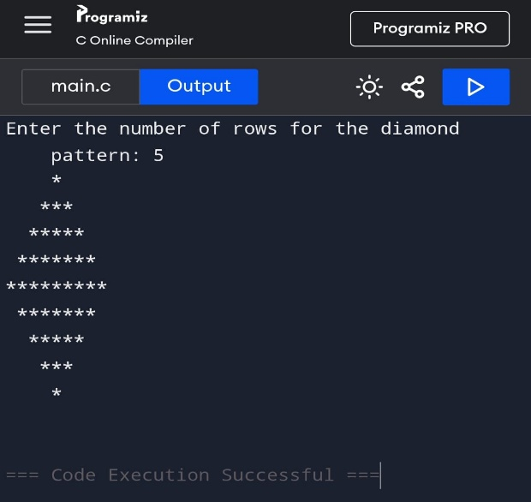

5.#include <stdio.h>

int string_length(char *str) {

int length = 0;

while (*str != '\0') {

length++;

str++;

}

return length;

}

int main() {

char str[100];

printf("Enter a string: ");

fgets(str, sizeof(str), stdin);

char *newline = str;

while (*newline) {

if (*newline == '\n') {

*newline = '\0';

break;

}

newline++;

}

int length = string_length(str);

printf("The length of the string is: %d\n", length);

return 0;

}

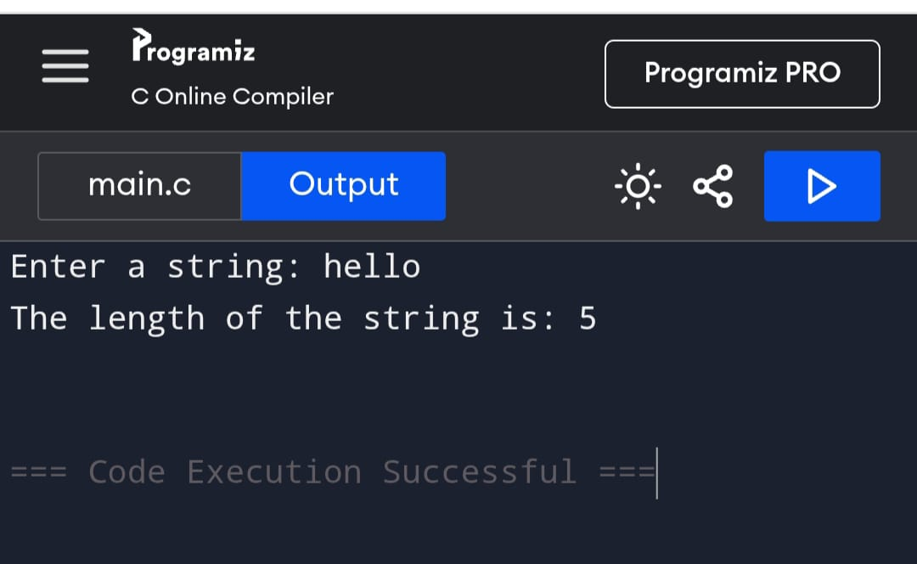

6.#include <stdio.h>

int gcd(int a, int b) {

if (b == 0) {

return a;

}

return gcd(b, a % b);

}

int main() {

int a, b;

printf("Enter two numbers: ");

scanf("%d %d", &a, &b);

int result = gcd(a, b);

printf("GCD of %d and %d is %d\n", a, b, result);

return 0;

}

